**Subhan Bin Yousaf**

**Section B**

**481281**

**FOP Lab Manual 8**

**Home Tasks**

**Task 1 :**

#include <iostream>

using namespace std;

int main () {

int arr[6];

int o;

for (int i=0;i<6;i++ ){

cout<< "Enter entry number "<<i+1<<" : ";

cin>>o;

arr[i] = o;

}

int a = arr[0];

int b = 1;

for (int i = 0; i < 6; i++) {

int t = 1;

for (int j = i + 1; j < 6; j++) {

if (arr[i] == arr[j]) {

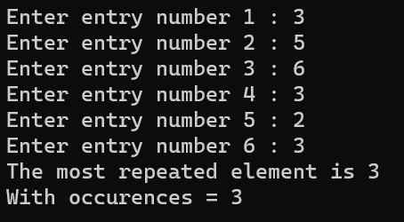t++;

}

}

if (t > b) {

b = t;

a = arr[i];

}

}

cout << "The most repeated element is " << a << endl;

cout << "With occurences = " << b;

return 0;

}

**Task 2 :**

#include <iostream>

using namespace std;

int main () {

int arr[8] ;

int a;

for (int i=0;i<8;i++) {

cout << "Enter Entry " << i+1 << " : ";

cin>>a;

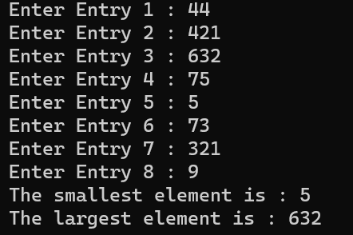 arr[i]=a;

}

for (int i = 0; i < 7; i++) {

for (int j = i + 1; j < 8; j++) {

if (arr[j] < arr[i]) {

int temp = arr[j];

arr[j] = arr[i];

arr[i] = temp;

}

}

}

cout << "The smallest element is : " << arr[0] <<endl;

cout << "The largest element is : " << arr[7];

return 0;

}

**Task 3 :**

#include <iostream>

using namespace std;

int main () {

int arr[5];

for (int i = 0; i < 5; i++) {

cout<< "Enter element "<<i+1<<" : ";

cin >> arr[i];

}

cout<<"The array is : ";

for (int i=0; i<5; i++) {

cout<<arr[i]<<" , ";

}

cout<<endl;

cout << "Element at position [2] before swapping is : " << arr[2] << endl;

cout << "Element at position [4] before swapping is : " << arr[4] << endl;

int temp = arr[4];

arr[4] = arr[2];

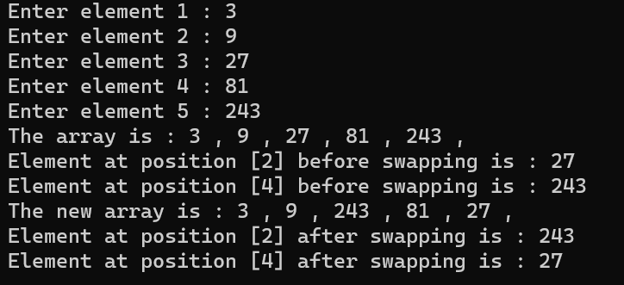arr[2] = temp;

cout<<"The new array is : ";

for (int i=0; i<5; i++) {

cout<<arr[i]<<" , ";

}

cout<<endl;

cout << "Element at position [2] after swapping is : " << arr[2] << endl;

cout << "Element at position [4] after swapping is : " << arr[4] << endl;

return 0;

}